LINE CHART - EMPLOYEE PERFORMANCE TREND
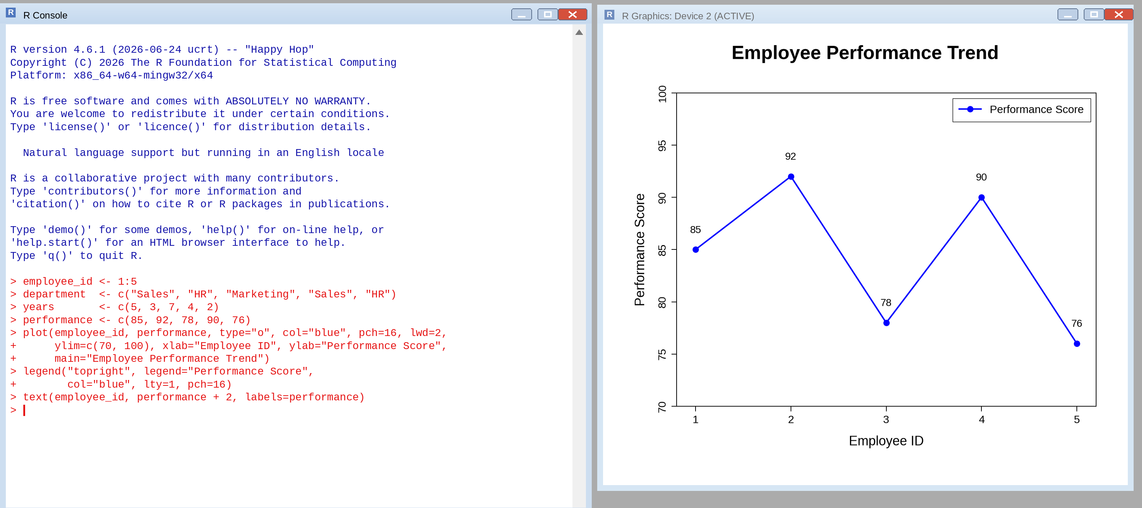
BAR CHART - EMPLOYEES BY DEPARTMENT
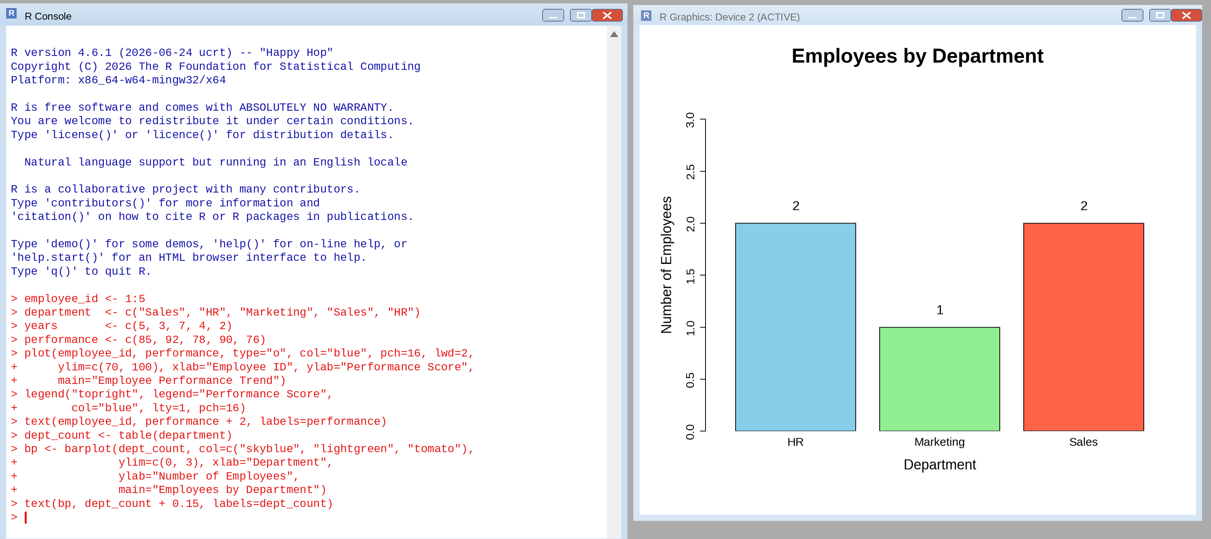
SCATTER PLOT - YEARS OF SERVICE VS PERFORMANCE SCORE
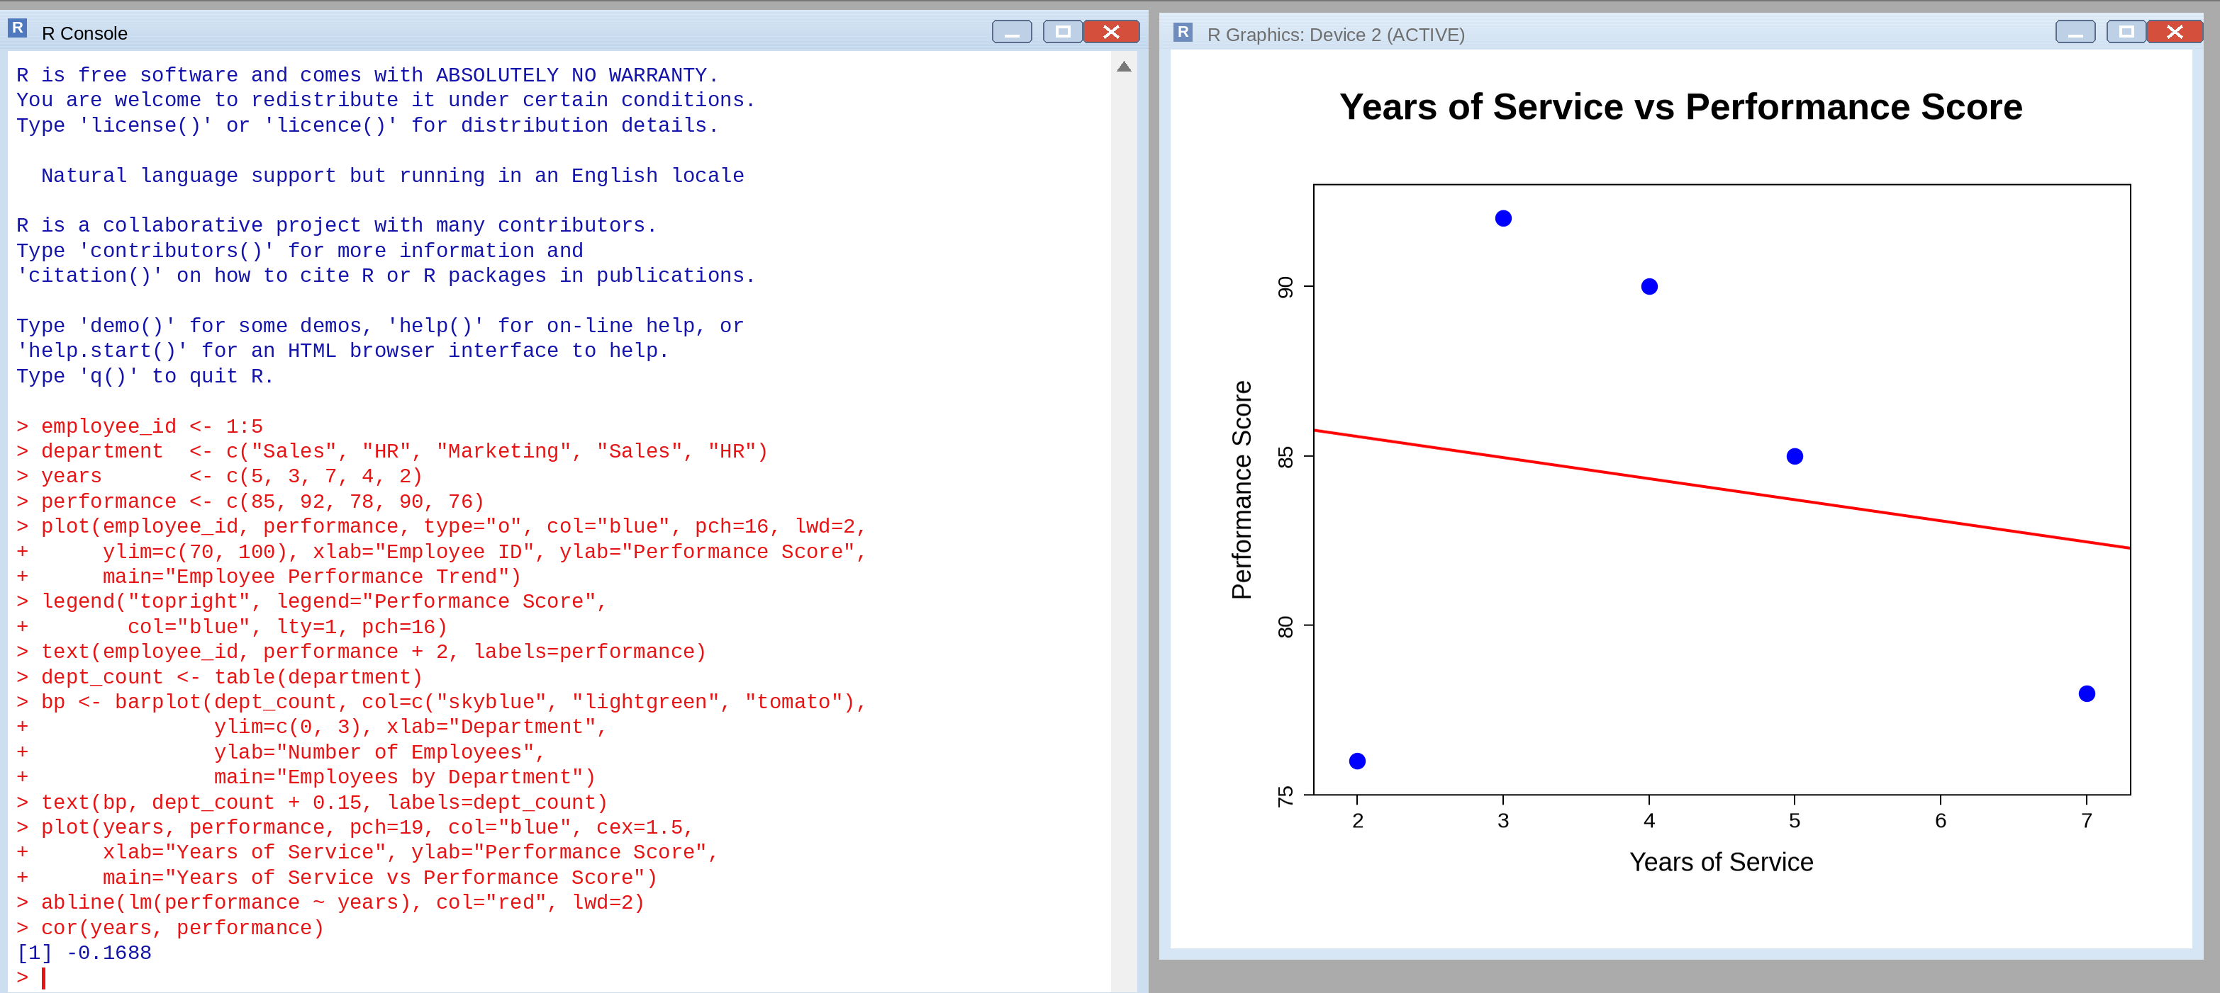
Insights
- The correlation coefficient is r = -0.17 (R-squared about 0.03), so there is essentially no linear relationship between years of service and performance score.
- The fitted line has a slope of about -0.62, meaning a tiny, almost flat decline of roughly 0.6 points per extra year of service.
- The top score (92) belongs to an employee with 3 years of service, while the most experienced employee (7 years) scored 78. Experience alone does not predict performance here.
- With only 5 employees this result is not statistically reliable. Factors such as department, role or workload should be examined with a larger dataset.
TABLEAU DASHBOARD - LINE CHART AND BAR CHART
